**PTU CSE SYLLABUS**

**GUIDE**

**MID TERM REPORT**

OF MAJOR PROJECT

**BACHELOR OF TECHNOLOGY**

COMPUTER SCIENCE AND ENGINEERING

SUBMITTED BY

JASWANT SINGH BALJEET SINGH

([jaswanttaur0092@gmail.com](mailto:jaswanttaur0092@gmail.com)) ([bsinghs.007@gmail.com](mailto:bsinghs.007@gmail.com))

Univ. roll no.-1183706 Univ. roll no.- 1183691

Class roll no.-105147 Class roll no.-105149

Contact no. – 9646863063 Contact no.- 8591854049

Batch- 2011 Batch- 2011



**GURU NANAK DEV ENGINEERING COLLEGE**

**LUDHIANA**

**DECL­­­­ARATION**

We hereby certify that the project PTU CSE Syllabus Guide by Jaswant Singh University Roll No. 1183706, Baljeet Singh University Roll No. 1183691 in partial fulfillment of requirements for the award of degree of B.Tech. (Computer Science & Engg.) submitted in the Department of Computer Science and Engineering at GURU NANAK DEV ENGINEERING COLLEGE, is an authentic record of our own work carried out under the supervision of Mr. Amanpreet Singh Brar.

Jaswant Singh Baljeet Singh

(1183706) (1183691)

This is to certify that the above statement made by the candidate is correct to

the best of my knowledge.

Mr. Amanpreet Singh

HOD(CSE)

(Mr.Vivek Thapar) (Amanpreet Singh Brar)

Project Coordinator H.O.D CSE

**ACKNOWLEDGEMENT**

We would like to express a deep sense of gratitude and thanks profusely to Mr. Amanpreet Singh. Without the wise counsel and able guidance, it would have been impossible to complete the report in this manner. The ever helping nature and limitless patience were constant source of inspiration during the work. Making this project has also helped me in doing a lot of Research work and I came to know about so many new things.

**Jaswant Singh (1183706)**

**Baljeet Singh (1183691)**

**INDEX**

|  |  |  |
| --- | --- | --- |
| **Sr. No** | **TOPIC** | **Page No.** |
| 1. | Introduction to Project | 1 |
| 2. | Technology to be used | 2 |
| 3. | Requirement Analysis | 4 |
| 4. | Feasibility Study of the Project | 5 |
| 5. | Significance of the project | 6 |
| 6. | Methodology/ Planning of Work | 7-8 |
| 7. | Snapshots | 9-11 |
| 8. | Conclusion | 12 |
| 9. | Bibliography | 13 |

**1. Introduction**

**Project- PTU CSE Syllabus Guide**

**PTU CSE SYLLABUS GUIDE** is a project dealing with the ptu cse students problems of finding the good & quality resources for their study. So this project could be one and only to deal with it. The ptu cse syllabus guide will include the notes, books, question banks, previous years question papers, and hopefully quiz. Thus the students need not have to look any further for studying their current subjects and hopefully this will decrease the burden on the students of finding the different topics from the internet. Thus this project could prove to a game changer for ptu cse students, whether they are doing the thorough study of the subject or just walking through the subject during sessional or examination. The project is open source & is under the Apache License, Version 2.0. It could prove to be the time effective solution for the students. This project will work on all major platforms including windows, android, ios, windows phone, blackberry, Ubuntu OS, Firefox OS etc.

The **PTU CSE SYLLABUS GUIDE** includes student registration/login page, student page. In Student Registration students can fill their information to get the homepage. The homepage which is the user panel will include links to different semester pages. The different semester pages will have the further subject pages and the subject pages will have the notes, question banks, quiz, previous year question paper for different subjects. In starting of the project student fills his login information and if he is not registered he has to before using this guide. When the new user registers the admin of DB have right to give the privileges to the user. So after the admin gives rights to the user, then the user will be able to login with the information he has provided during the registration. After login the user will be taken to his profile page, where he can traverse to any subject by clicking the links or can just search for the subject or the topic and the results will be displayed instantly without refreshing.

**2.Technology to be used:-**

The front end used in this project is the HTML, CSS, jQuery, PHP and the backend is designed with the help of MYSQL 5.0.

**2.1 HTML:-** HTML stands for hypertext markup language.

* A markup language is a set of markup tags
* The tags describe document content
* HTML documents contain HTML tags and plain text
* HTML documents are also called web pages

**2.2 CSS:-** CSS stands for Cascading Style Sheets.

* Styles define how to display HTML elements
* Styles were added to HTML 4.0 to solve a problem
* External Style Sheets can save a lot of work
* External Style Sheets are stored in CSS files

**2.3 jQuery:-** jQuery is a lightweight, "write less, do more", JavaScript library. Features are

* HTML/DOM manipulation
* CSS manipulation
* HTML event methods
* Effects and animations
* AJAX

**2.4 PHP:-** PHP is server scripting language, and is a powerful tool for making dynamic and interactive Web pages quickly. PHP is widely used, free and efficient alternative to competitors such as Microsoft’s ASP.

* PHP is an acronym for hypertext preprocessor
* PHP is widely used, open source scripting language
* PHP script are executed on the server
* PHP cost nothing, it is free to download and use.

**2.5 MySQL**- MySQL Queries can be used retrieve large amount of records from a database quickly and efficiently. Using standard SQL it is easy to manage database system without having to write substantial amount of code. It is portable used for relational databases easy to learn and understand interactive language dynamic database.

The **PTU CSE SYLLABUS GUIDE** includes student registration/login page, student page. In Student Registration students can fill their information to get the homepage. The homepage which is the user panel will include links to different semester pages. The different semester pages will have the further subject pages and the subject pages will have the notes, question banks, quiz, previous year question paper for different subjects. In starting of the project student fills his login information and if he is not registered he has to before using this guide. When the new user registers the admin of DB have right to give the privileges to the user. So after the admin gives rights to the user, then the user will be able to login with the information he has provided during the registration. After login the user will be taken to his profile page, where he can traverse to any subject by clicking the links or can just search for the subject or the topic and the results will be displayed instantly without refreshing.

**3. Requirement Analysis**

This phase define the requirement of the software i.e. it defines the tools and equipments which are used for the development of the software. Following are the hardware and software requirements for building this application:

**HARDWARE**

Processor 1.70 GHz and Above

Main Memory 512 MB.

Disk Space 100 MB.

Keyboard ANY

Mouse ANY

Monitor ANY

**SOFTWARE**

Operating System Windows, Linux.

Software Apache server2.2, PHP 5.4.3

Data Base MySQL

* 1. **Feasibility Study of the Project**

At this stage the client’s or the user’s needs are analyzed, information about the project is gathered and the requirements of the system are collected and analyzed. The user’s expectation for the system implementation is studied and the proposed solution is offered.

**a) Technical Feasibility: -** If we talk about the technical feasibility of this project then it requires the resources and the technology to be available. This project requires PHP and MySQL software for the frontend and backend respectively which are very easily available. Moreover the requirements of the hardware are also low.

**b) Economic Feasibility:-** As per the cost considerations, this project requires a low cost to build up including the hardware and the software cost. The cost of implementation is also fair enough to implement this application.

**c) Operational Feasibility: -** As the project is made keeping in mind the various requirements of the user, it is nearly sure that it must be used by the user if developed and implemented and will not give any large problems on the site of implementation.

**5. Need and Significance of the project**

* This project is going to help the students by providing them all the resources needed for study from single source.
* This project will help the students during the exams when scanning to the subject is required.
* This project will also help the teachers.
* This project thus is not the benefit of one member, it is the benefit of the community.
* The students can take the quizzes time by time to boost up their memory pertaining to subject.

**6.Methodology/ Planning of Work**

The project will be follow the bottom up approach. First the smaller modules like login/registration page, semester pages, subject pages, contact us, about us etc. will be created and then they all will be combined for the completion of the project. In starting of the project student fills his login information and if he is not registered he has to before using this guide. When the new user registers the admin of DB have right to give the privileges to the user. So after the admin gives rights to the user, then the user will be able to login with the information he has provided during the registration. After login the user will be taken to his profile page, where he can traverse to any subject by clicking the links or can just search for the subject or the topic and the results will be displayed instantly in the current working windows.

6.1 Flow diagram of PTU CSE SYLLABUS GUIDE

Login/Registration

Semesters

Tutorial

Contact Us

Search

3rd

1st

2nd

8th

7th

6th

5th

4th

Sub n

Sub n

Sub 2

Sub 1

Books

QP

Quiz

Notes

Note

Sub- Subject.

QP- Question papers pertaining to subject.

Books- Books pertaining to different subjects

Notes- Notes pertaining to subject.

Quiz – Quiz pertaining to different subject.

**7. SNAP SHOTS**

**7.1 WEB APP SNAPSHOT**

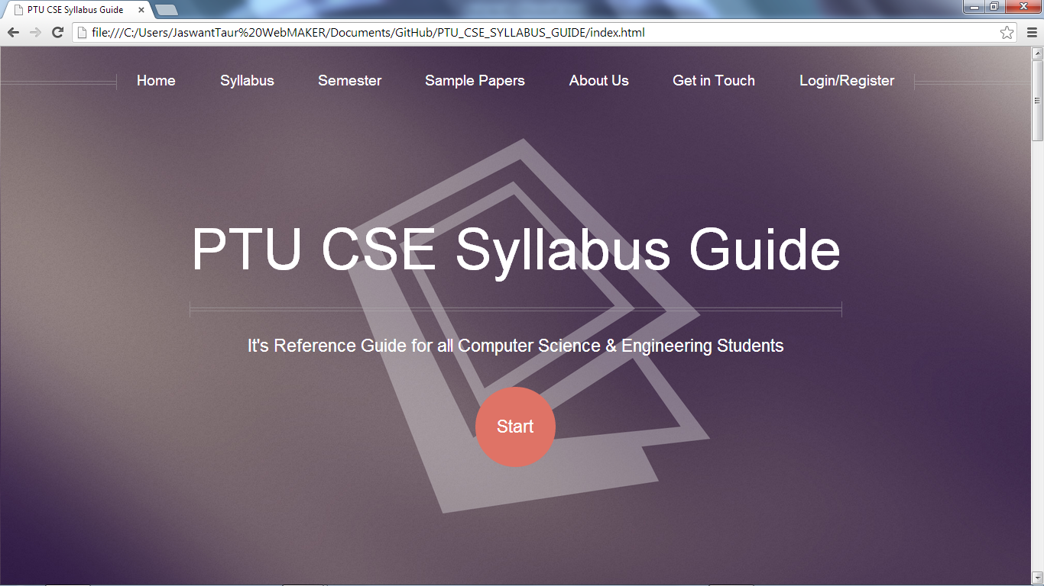

**Fig no. 1**

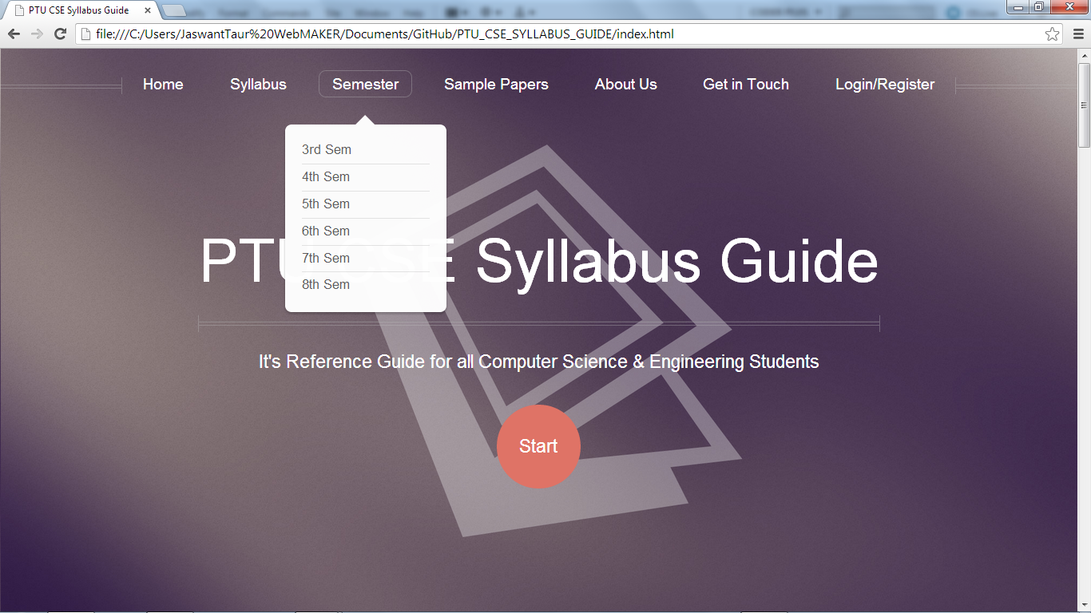

**Fig no. 2**

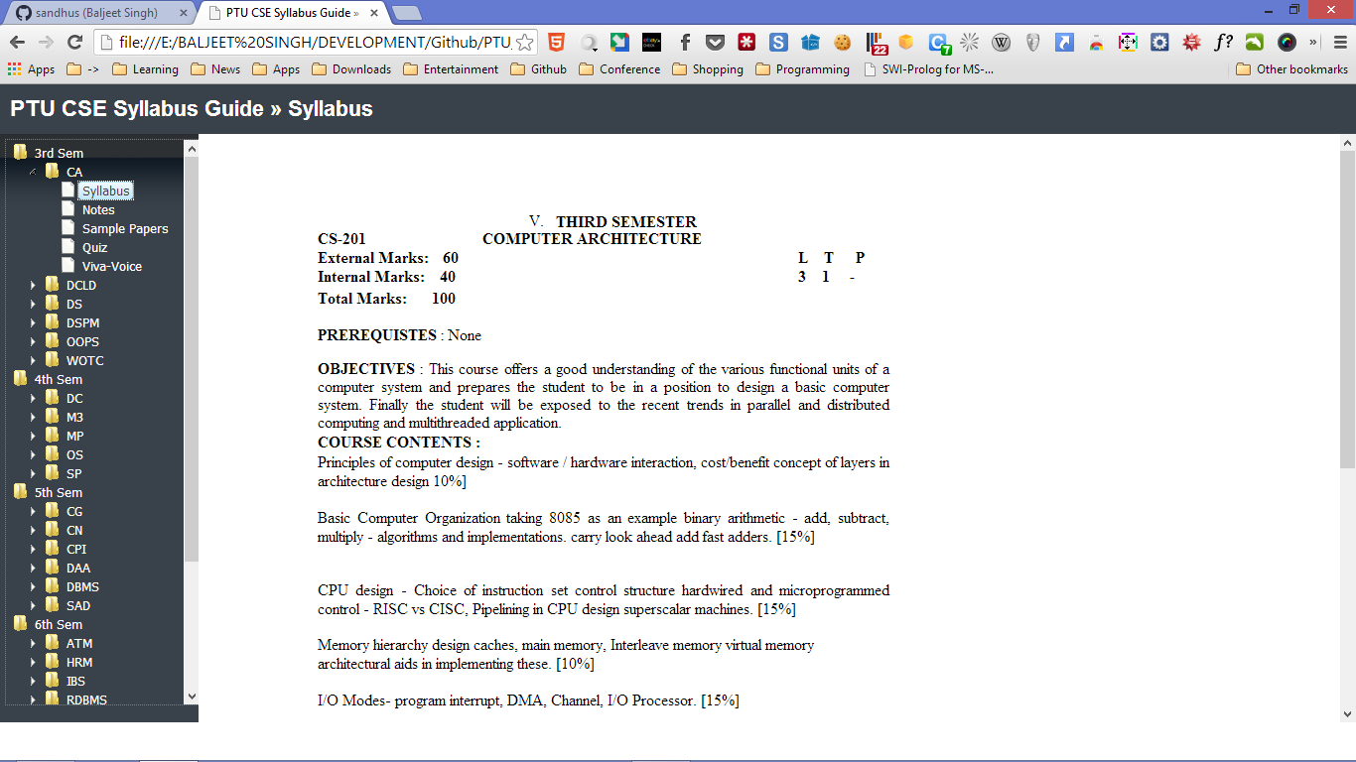

**Fig no. 3**

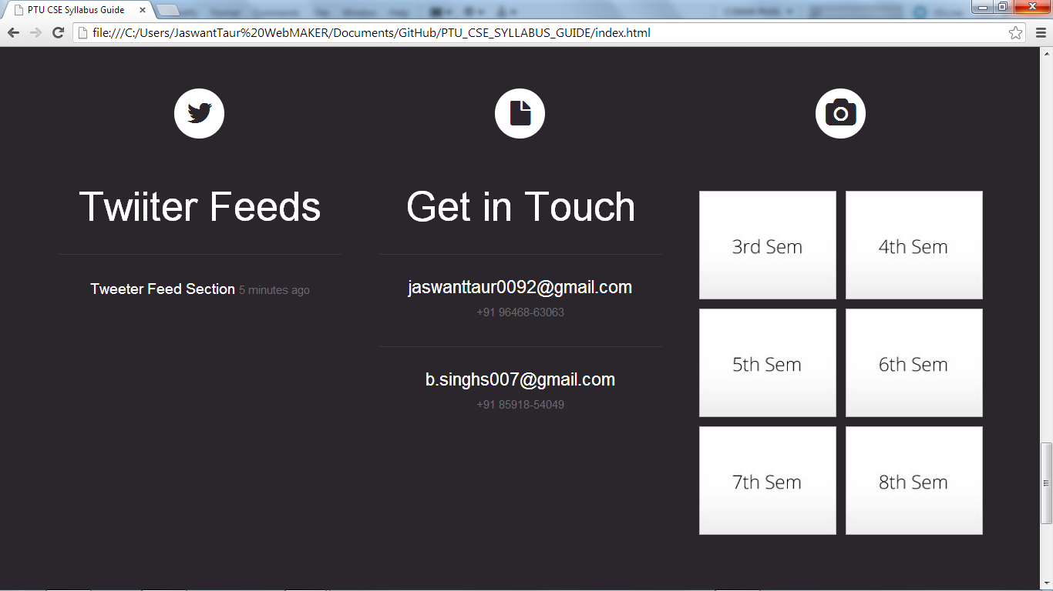

**Fig no. 4**

**7.2 ANDROID APP SNAPSHOT**

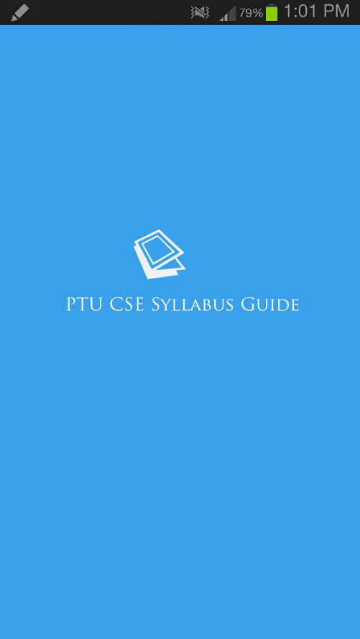**­­­­­­­­­**

**Fig no.5**



**Fig no.6**

**8. Conclusion**

The application is made keeping in mind the requirement of the PTU CSE Students. Syllabus and some study material have been added. In th future we will be adding more study material and related content.

**9. Bibliography**

* <http://smashingmagazine.com>
* <http://www.tutsplus.com>
* <http://www.1stwebdesigner.com>
* Appgvyer Steroids
* Getting good with javascript.